Models of Excellence Qs:
1. What was compelling for your students about this?
This project was compelling to students in many ways. The majority of students were able to actually interview their “hidden figure” of science through a Google Meet, which brought an authentic sense of realness to the project and the work. Additionally, we hosted a Cougar Cinema night at the school where student films were shown to families and the community. This authentic audience was a powerful piece for students as they knew it was bigger than themselves, the classroom, or the school.
2. What were the challenges?
Challenges included learning and teaching students new technology, and finding ways to create space for quiet interviews and recording. Time is always a challenge in these large projects and expeditions, as well. Finding time to give students feedback as they work through their multiple drafts is hard, but always worthwhile when you see their beautiful work and high quality outcomes.
3. What makes this particular piece a model for other students?
Students collaborated in a significant way from researching a “hidden figure” of science to drafting a script, to interviewing a professional, to creating, recording, and editing a video. The craftsmanship involved requires students to delve into authentic, real-world skills that they can take with them beyond the classroom.
4. What would be your advice to a teacher that is inspired by this project?
Start small and build piece by piece. Each year we complete this expedition with students, we take it a bit further and build upon our foundation.

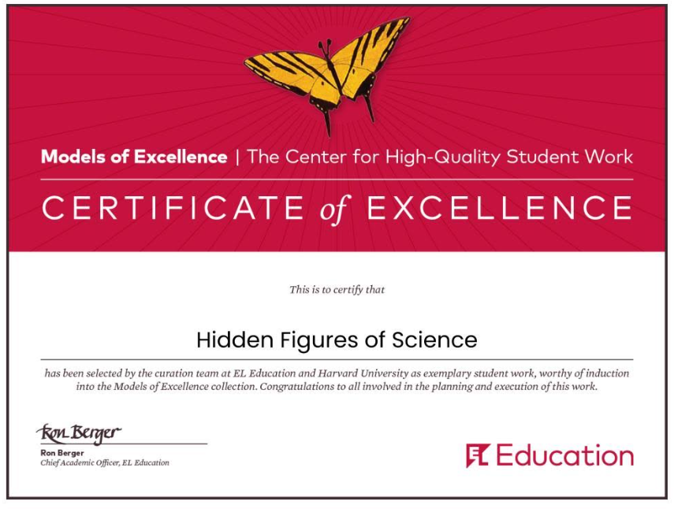

Title: Hidden Figures of Science
Submitted by: Paige Hahn and Autumn Rivera
School: Glenwood Springs Middle School
City: Glenwood Springs
State: Colorado
Email: paigeh@rfschools.com, arivera@rfschools.com

Description: Sixth-grade students at Glenwood Springs Middle School read the Module 4 EL ELA 6th Grade text Hidden Figures by Margot Lee Shetterly while learning about the civil rights movement and the importance of analyzing multiple perspectives through history - before enhancing the performance task. The guiding question that steered learning is: "Why is it important to study the accomplishments of "hidden figures" and others whose stories have gone unrecognized?" We partnered with local film festivals, including Aspen Film and 5 Point Film to show students exemplars of documentary film as a powerful tool for story-telling, perspective, and voice; students got to speak with documentary filmmakers and subjects. In Science class, students chose a partner and a “hidden figure” of science to research. Each chosen scientist pushes the boundaries of representation in science, connecting back to the novel and the guiding question. Students researched their “hidden figure”, contacted their scientist or another expert to interview, wrote a documentary script, made a storyboard, filmed in beautiful community spaces, and compiled all work into a WeVideo, where they began editing to produce a 5-minute documentary. Over the following weeks, students interviewed their “hidden figure” scientists, then created biographical documentaries to honor and tell the story of their chosen “hidden figure” of science while demonstrating mastery of documentary film techniques. To culminate and celebrate, we hosted a cross-grade-level (6th and 7th) Celebration of Learning called the Cougar Cinema, wherein we rolled out a literal red carpet for student-filmmakers to walk as they entered our very own GSMS Film Festival. Each film screening ended in a filmmaker panel where students shared their most significant takeaway from the project and answered questions from family and the community. Finally, students showed gratitude and honored the “hidden figures” they interviewed by sharing their documentaries through an email of thanks.

Product Planner/Timeline:
- Follow EL ELA Curriculum to read Hidden Figures and analyze articles about perspective and civil rights through Unit 2 before enhancing the performance task
- Partner with local film festivals to show examples and exemplars of HQ final project
- Choose a ‘hidden figure’ of science to research thoroughly and find a means of contact
- Write a script
- Create a storyboard
- Interview scientists via phone or Google Meet: You can view the collection of interviews here. Students wrote questions, and worked on professionalism as they met with scientists to ask questions about science and life.
- Work on edits in WeVideo, include documentary techniques: Used film-making structure from the Grade 7 Module 4 documentary project to stay consistent with EL learning and to prepare students for the following year
- Celebrate at a Celebration of Learning: Cougar Cinema Film Festival - a multi-grade-level celebration of student-made films

Exemplars and Examples:
“Serra Hoagland” by Olivia, Eliel, and Marco | https://drive.google.com/file/d/1gkd2CT-rqoQ8kiwzrFBhWeWT6QnA4-21/view
“Christina Liang” by Josie and Miah | https://drive.google.com/file/d/117Jna_YU8OHY3rwF9hltEF50AiJFLFwx/view
“Roderquita K. Moore” Hayden and Allison | https://drive.google.com/file/d/14BlQx-3cQ8-VrUqEZHXvsc_XFO7ezNuu/view
“Shaneka S. Lawson” by Raina and Jeyline | https://drive.google.com/file/d/15v4VI0d0p1N-edaZy3wxMSard0tj8LNt/view

Final Website Link (with all student-videos): https://sites.google.com/rfschools.com/cougar-cinema-2023/home

Rubric: 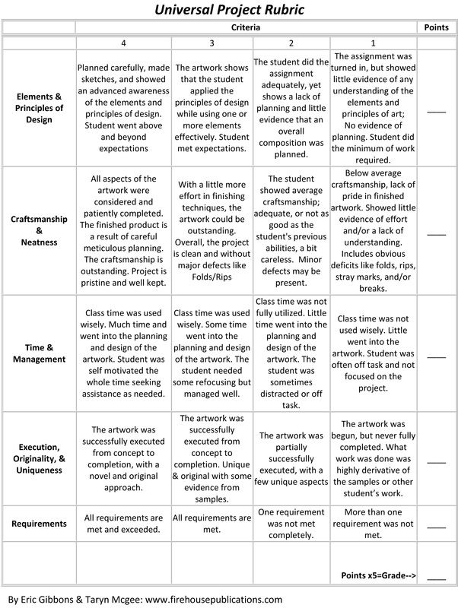

Module: Module 4: Hidden Figures

Assignment:
With a partner, create a 5-minute biographical documentary about your scientist. We will be using WeVideo to craft the final product. The purpose of this project is to teach others about a ‘hidden figure’ scientist, pushing the boundaries of representation in the field of science and considering multiple perspectives. The documentary will be based on the outline you develop, which will include your script, storyboard, interview, video clips, and documentary techniques.
Your script should include:
- A narrative lead introduction
- World/Community Problems,
- Details of scientist
- Accomplishments of Scientists
- Why it all matters
Your storyboard should include the following:
- Images (hand drawn or clip art) to represent each scene of your script (actors, camera angles, techniques)
- Captions telling what is happening and who is in the scene
Your WeVideo should include:
- The story of your remarkable ‘hidden figure’ of science
- Documentary film techniques
  - Images - moving and still
  - Zoom in and out
  - Voice-over narration
  - Interview with an expert (can be in-person, a recorded phone call, a recorded Google Meet or Facetime)
  - Graphics - computer or hand-drawn
  - Limited Text-on-screen
  - Statistics - numbers or percentages
  - Music - to make your teachers and scientists cry! :)
- 5 minutes in length
- Credits at the end
The Cougar Cinema Film Fest celebration will be held on May 23, 2023, at 6:00 pm at Glenwood Springs Middle School. On this evening, students will:
- Attend with family - if possible
- Dress professionally
- Donate baked goods to the bake sale, if you are able - proceeds benefit a well in South Sudan (7th) and the adoption of an orangutan (6th)
- Walk the red carpet - pose for the paparazzi
- Watch 6th and 7th grade films
- Stand up to answer questions and participate in a filmmaker interview after the film session

How This Project Can Be Useful:
- A product with an authentic audience since chosen scientists were contacted, interviewed, and emailed the website or documentaries. Also the documentaries were shown at the Cougar Cinema film fest COL - creates extra accountability.
- An engaging way for students to study science, through the interviews and research
- Connects school studies with real-life work.
- Broadens the view of who and what scientists look like and do. Increases representation.
- Care in editing and a celebration of people within the community, both writing and speaking.
- Authentically enhance a module performance task by expeditionizing learning and engagement, crossing content and collaborating between language arts and science.

Common Core Standards Language Arts:

