First Grade Expedition 1 Project Packet

Project Title: Warm Sun, Cool Moon

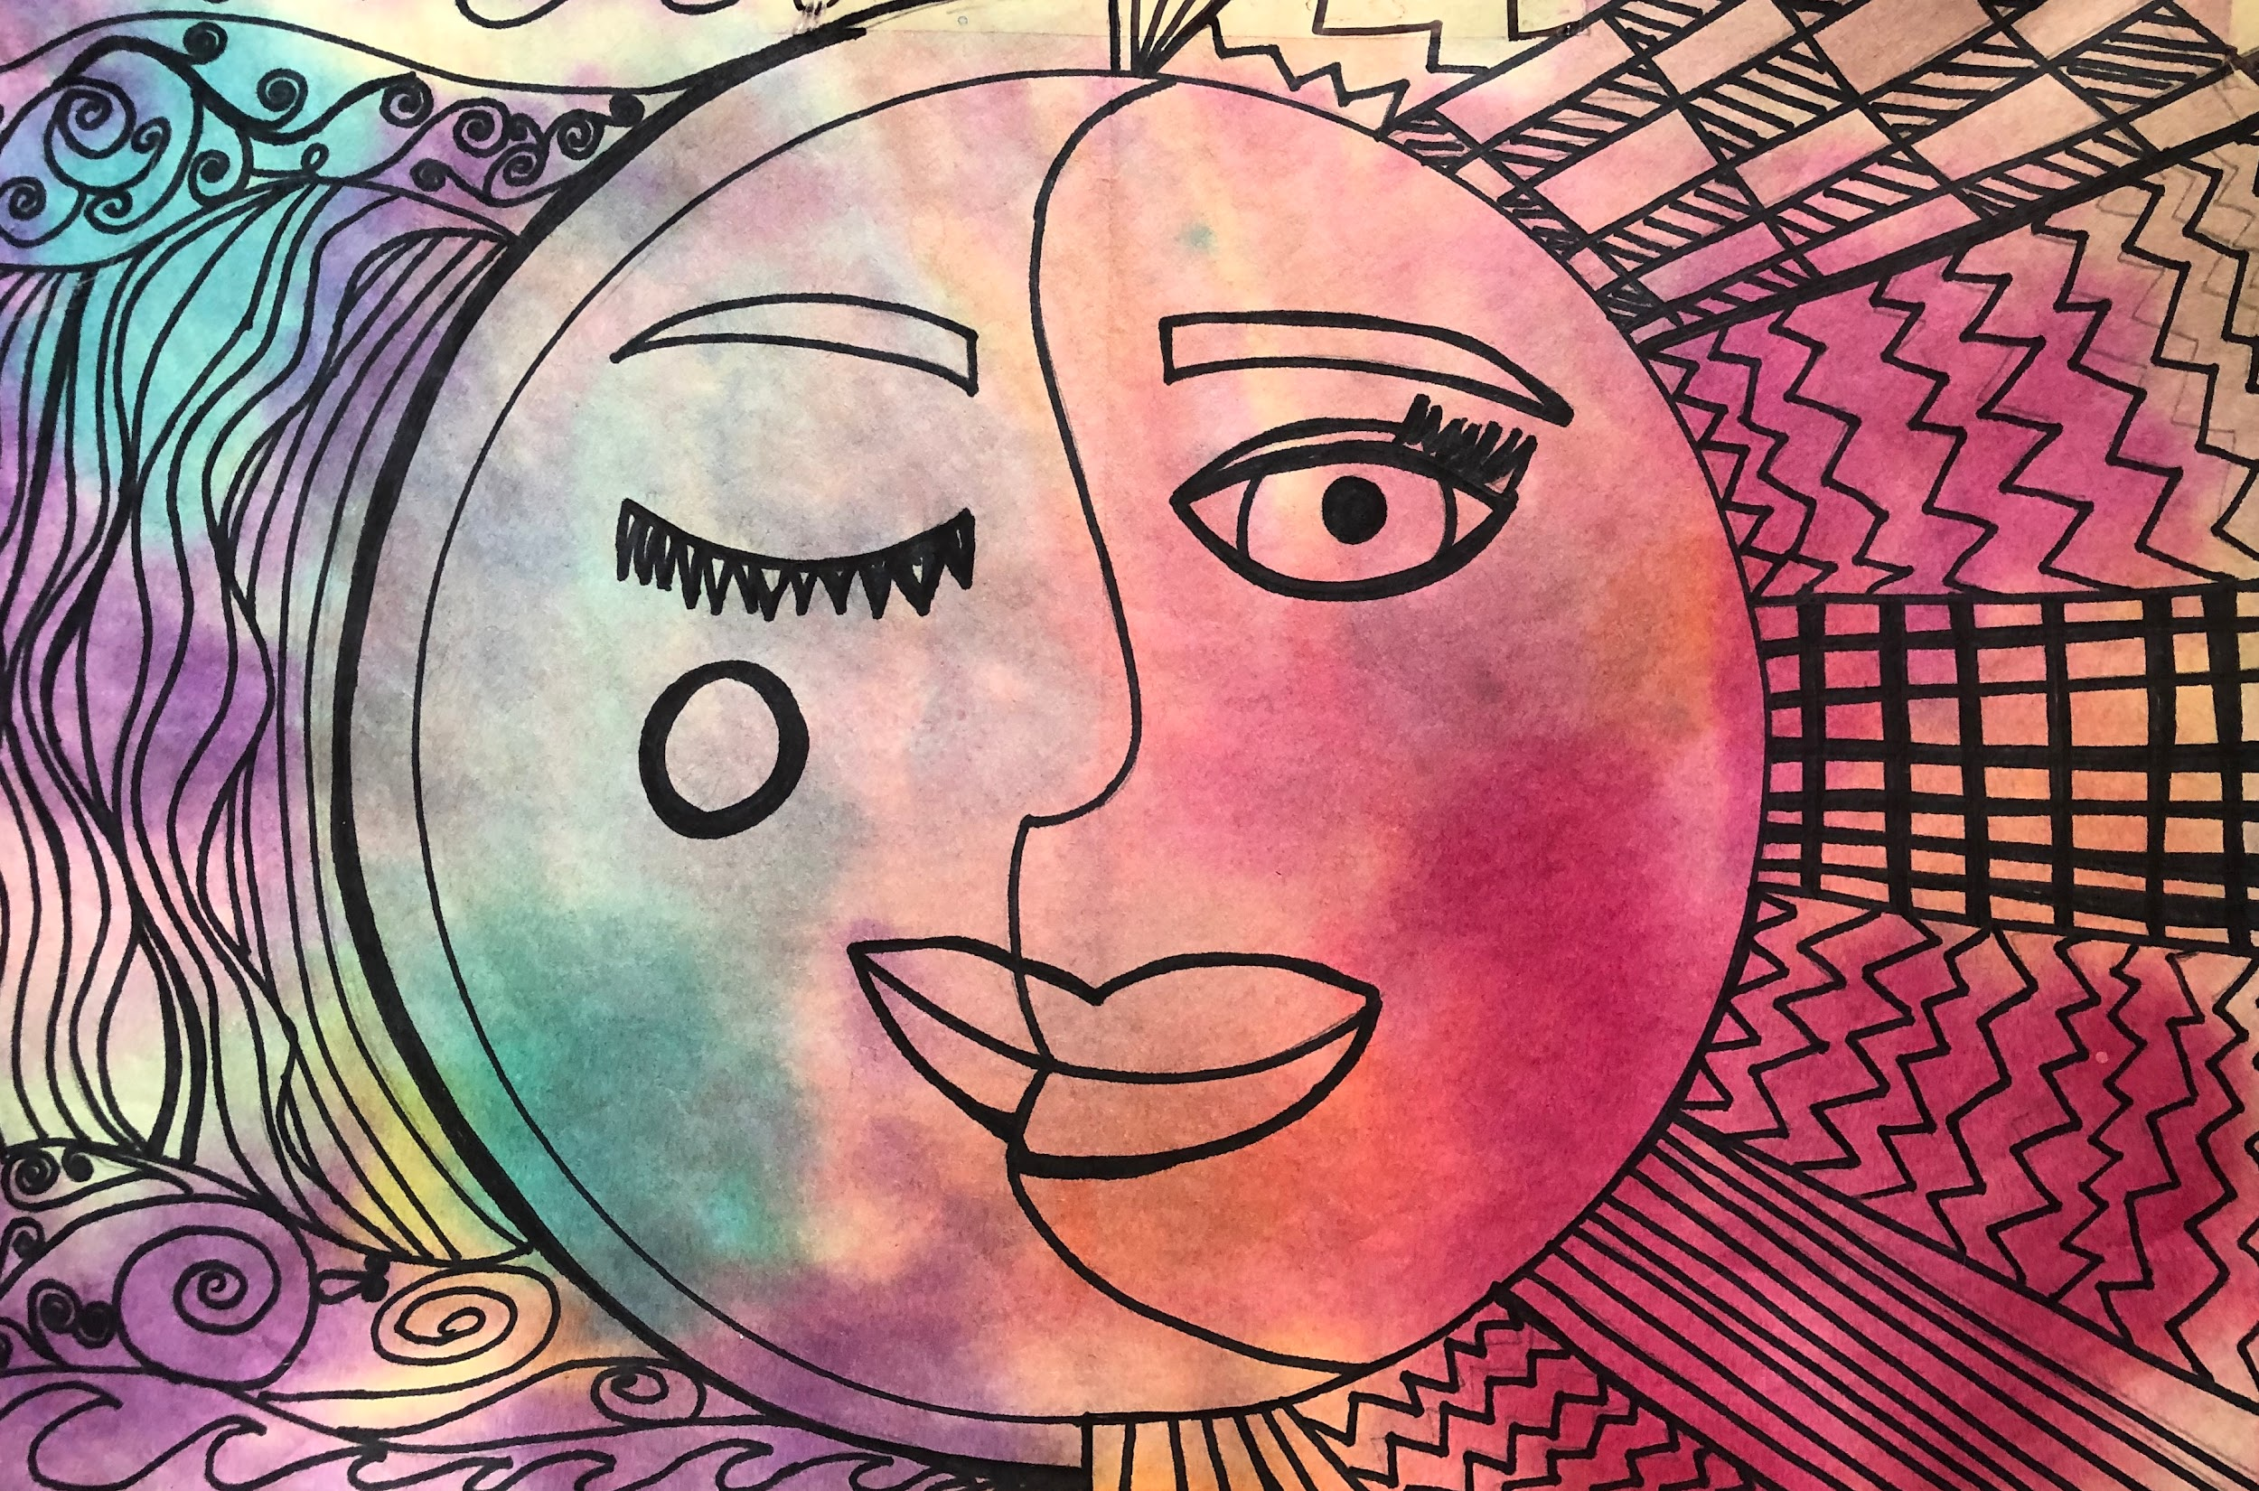
Ms. Jillian’s Example

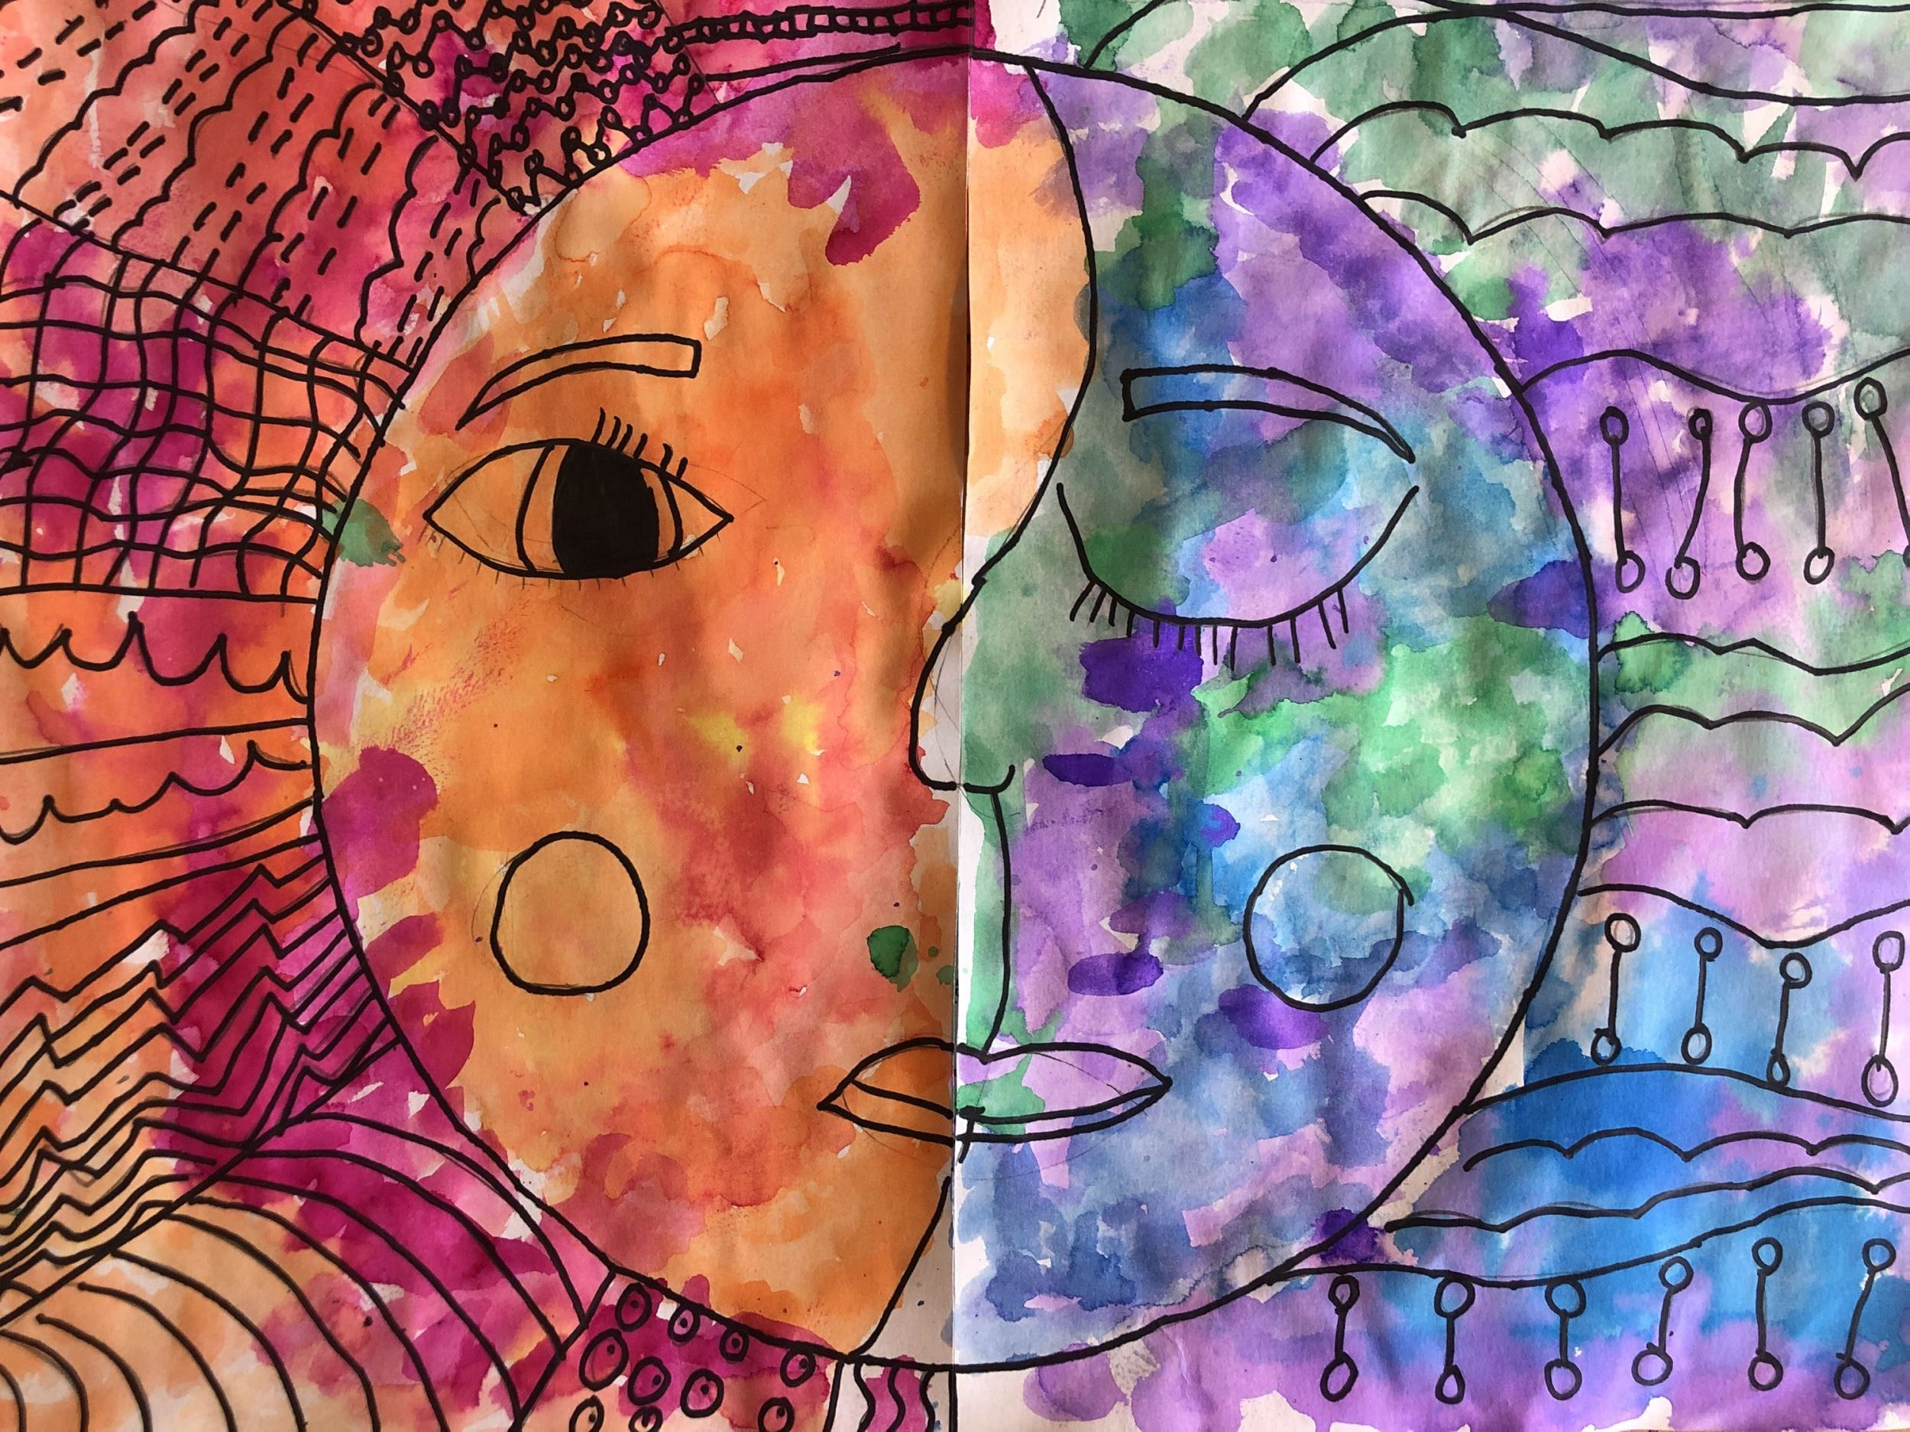
High Quality Student Example

Pacing Guide: what to do for the project and when

Dates | Weekly Project Steps | Items to turn into Google Classroom
Week 1  10/12/20  Completed Project Step due Friday, 10/16 | - Read or listen to How the Stars Came to Be by Poonam Mistry  - Begin and complete first draft  - Glow and Grow Self Reflection Protocol | - First draft  - Glow and Grow Graphic Organizer
Week 2  10/19/20  Completed Project Step due Friday, 10/23 | - Let’s Learn about Lines!  - Echo drawings  - Organic/Geometric line sorting | - Echo drawings  - Organic and Geometric Line Sort
Week 3  10/26/20  Completed Project Step due Friday, 10/30 | - Listen to Sun by Alison Oliver  - Begin and complete second draft  - Glow/Grow Self Reflection | - Second Draft  - Glow and Grow reflection
Week 4  11/2/20  Completed Project Step due Friday, 11/6 | - Begin final draft following along with directional video from Ms. Jillian: tracing circles, drawing background lines and facial features  - Glow/Grow Self Reflection | - In progress final draft--👩🏻‍🏫 Ms. Jillian will give you feedback this week  - Glow and Grow reflection
Week 5  11/9/20  Completed Project Step due Friday, 11/13 | - Read Moon by Alison Oliver  - Adjust final draft based on feedback from Ms. Jillian  - Continue final draft: line patterns and tracing pencil lines with a black marker  - Glow/Grow Self Reflection | - In progress final draft--👩🏻‍🏫 Ms. Jillian will give you feedback this week  - Glow and Grow reflection
Week 6  11/16/20  Completed Project Step due Friday, 11/20 | - Finish any remaining drawing steps  - Identify warm/cool colors  - Begin to add color to your work with high quality | - In progress final draft--👩🏻‍🏫 Ms. Jillian will give you feedback this week
Week 7  11/23/20  Completed Project due Monday, 11/30/20 | - Complete project by finishing any remaining coloring with high quality | - Finished project for grading

In Progress Projects from Last Year
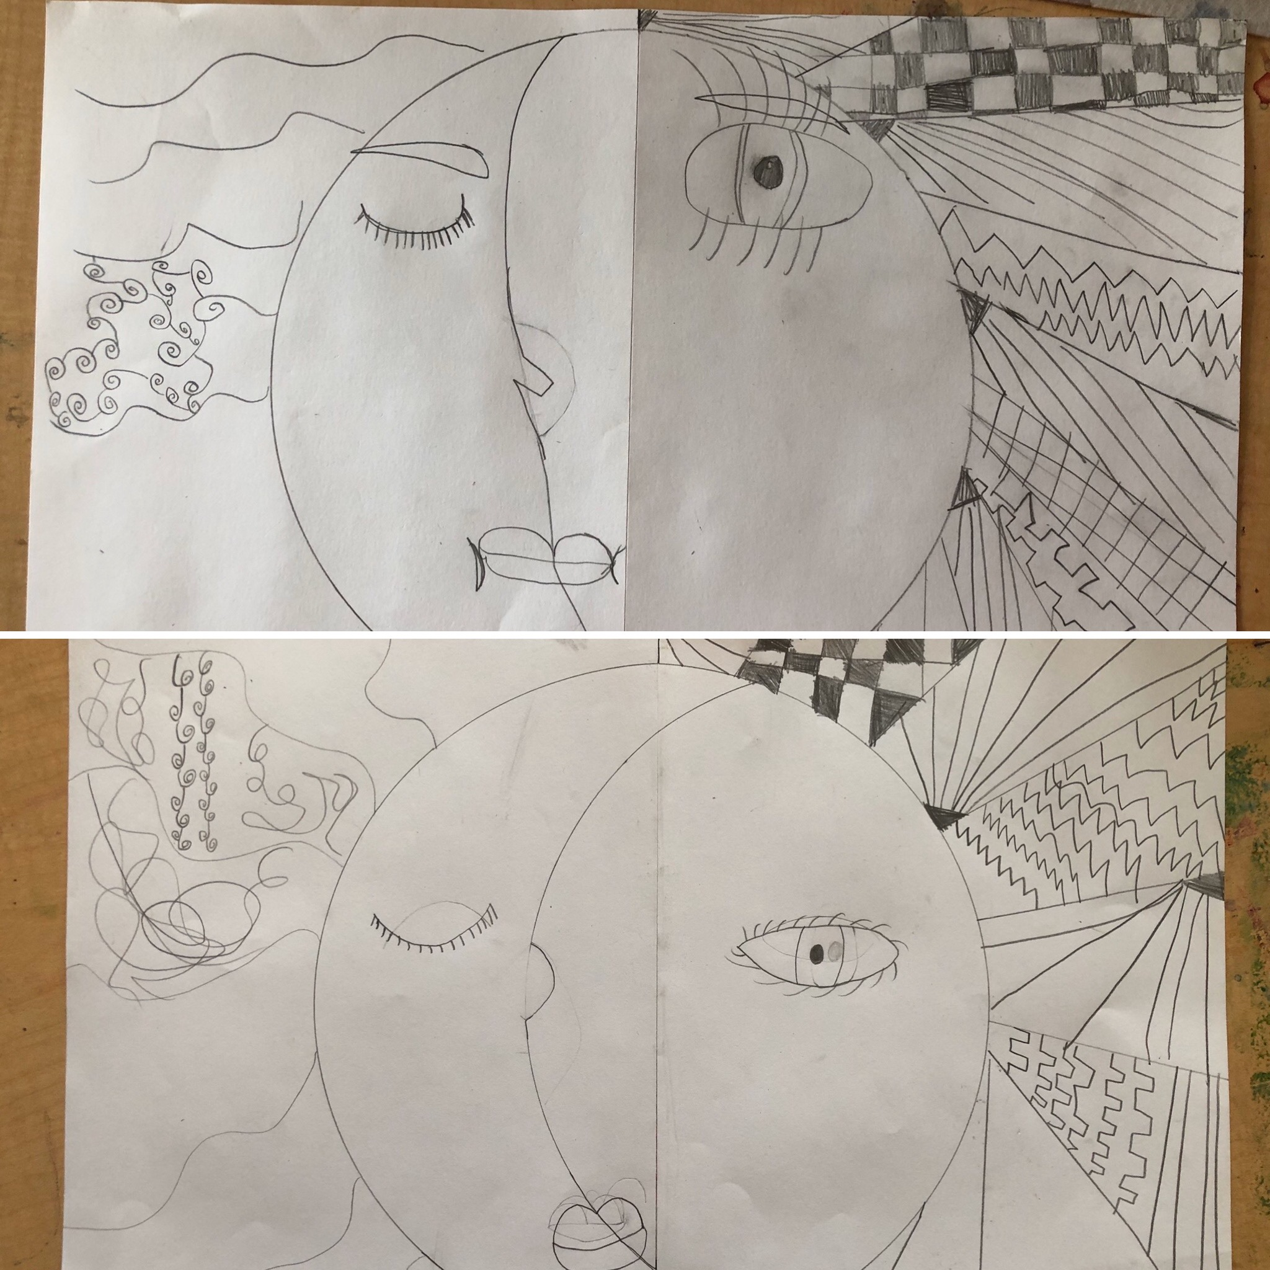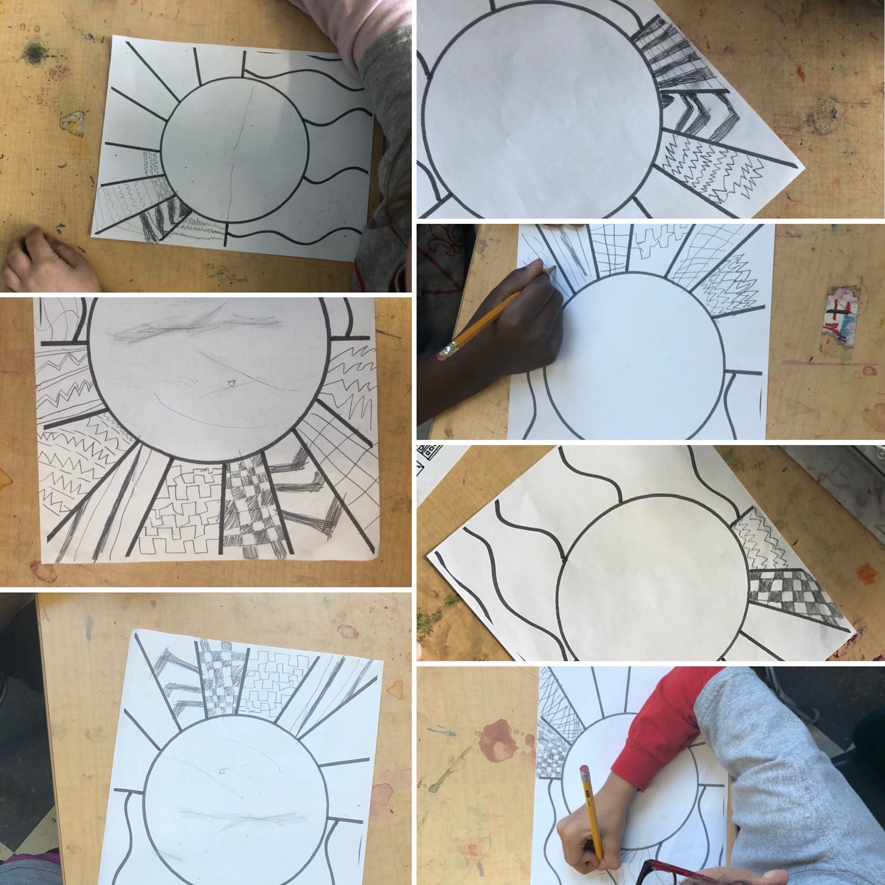

Resources for Week One

In order of use:

Due Friday by 8 p.m. in Google Classroom

- Draft sheet (front and back)

- Glow and Grow graphic organizer

Optional

- Glow and Grow coloring pages

Name:__________________________

Crew:________________________

Project Title: Warm Sun, Cool Moon

Project Step: First Draft
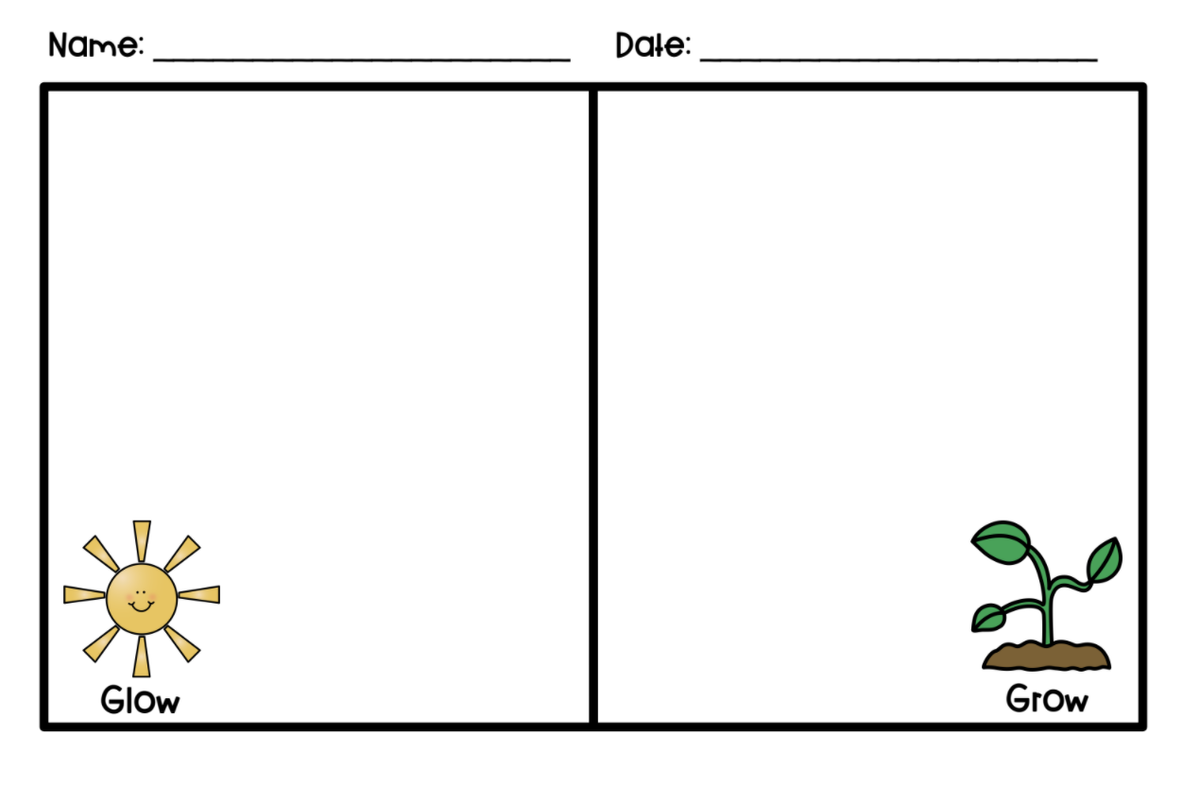
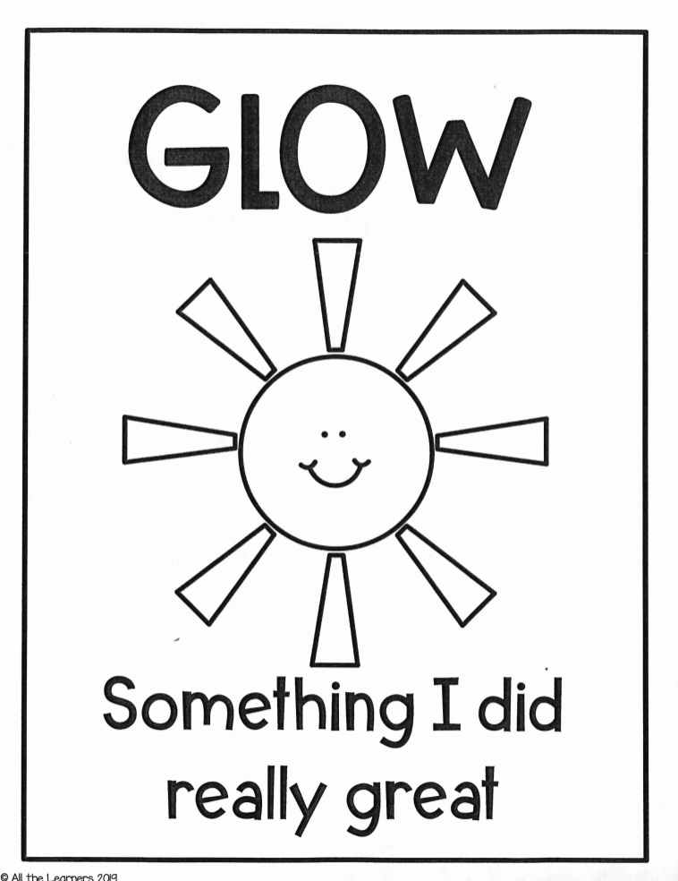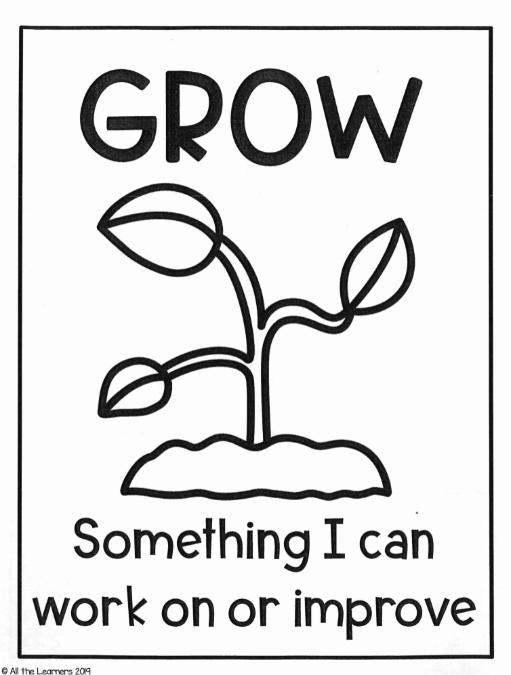
Any unused papers from this packet!
Thank you!

¡Cualquier papel no utilizado de este paquete!
¡Gracias!

Resources for Week Two

In order of use
Due Friday by 8 p.m. in Google Classroom:
- Echo Drawings

- Line Pattern Example Sheet--visual reference for line sort and second/final draft

- Geometric and Organic Line Sort (front and back)

Optional:
- Facial Feature practice

- Line tracing
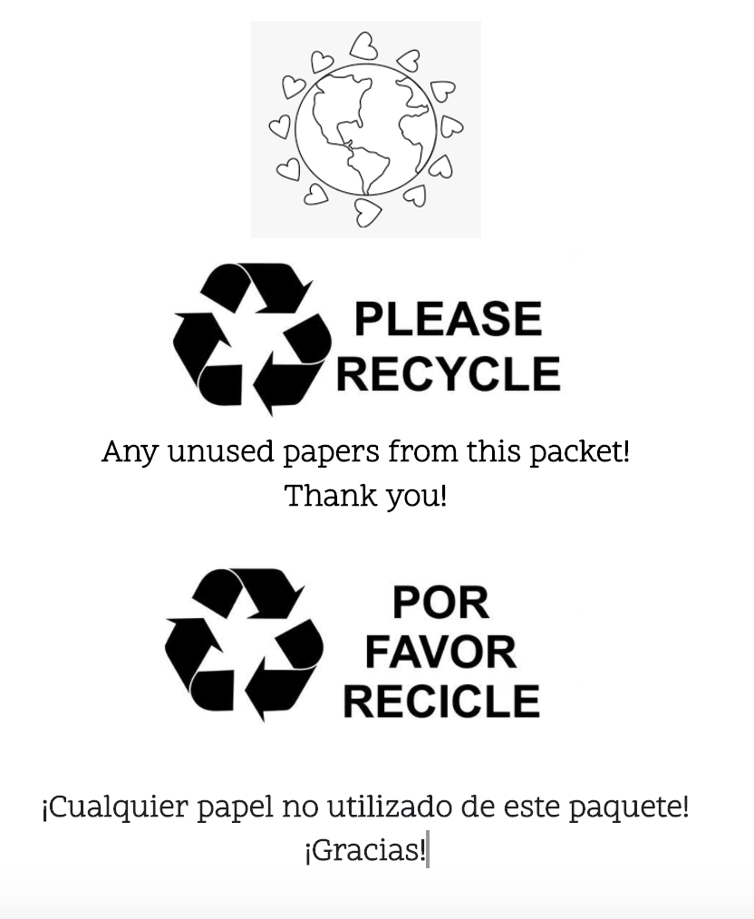
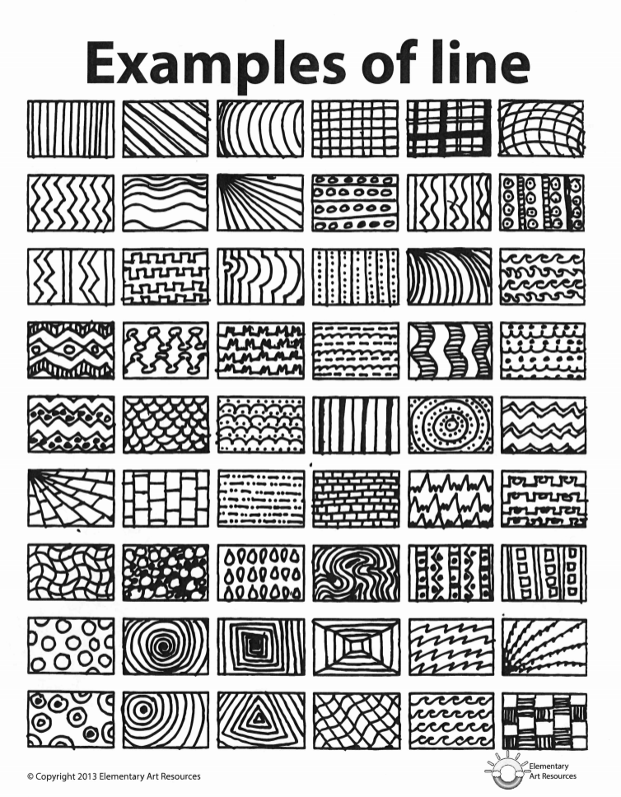
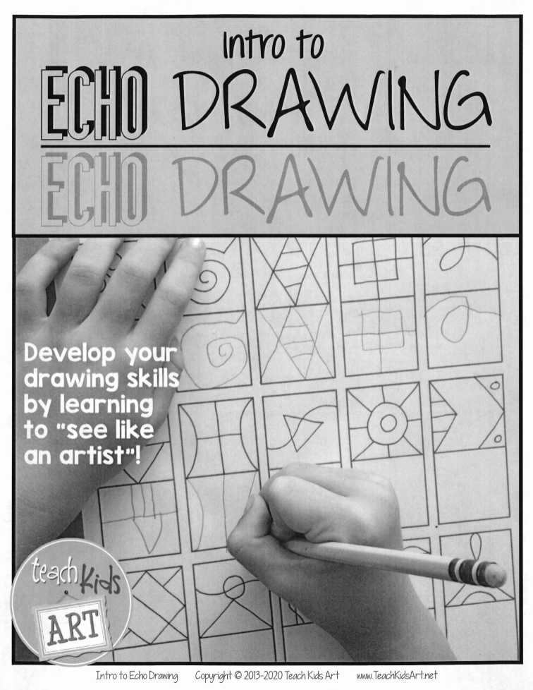
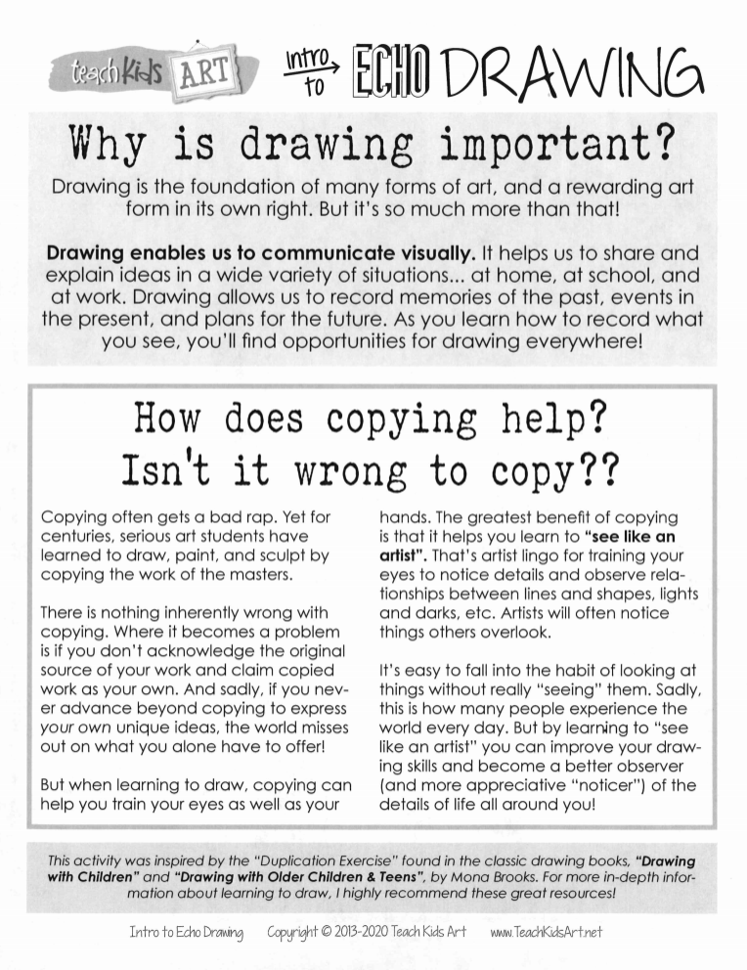
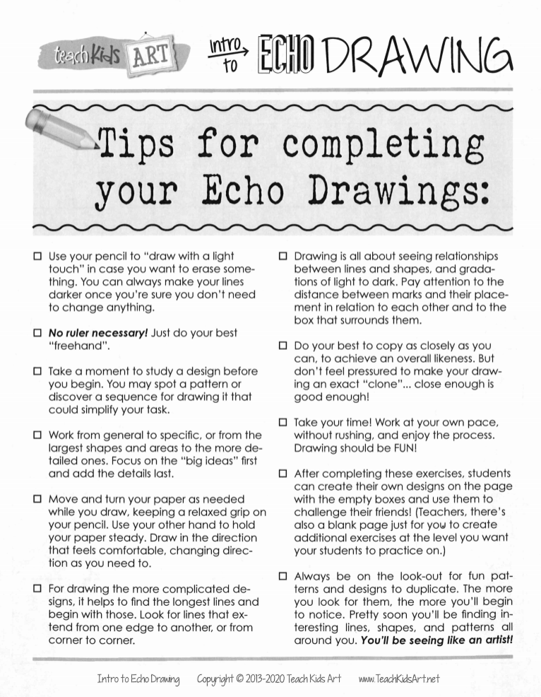
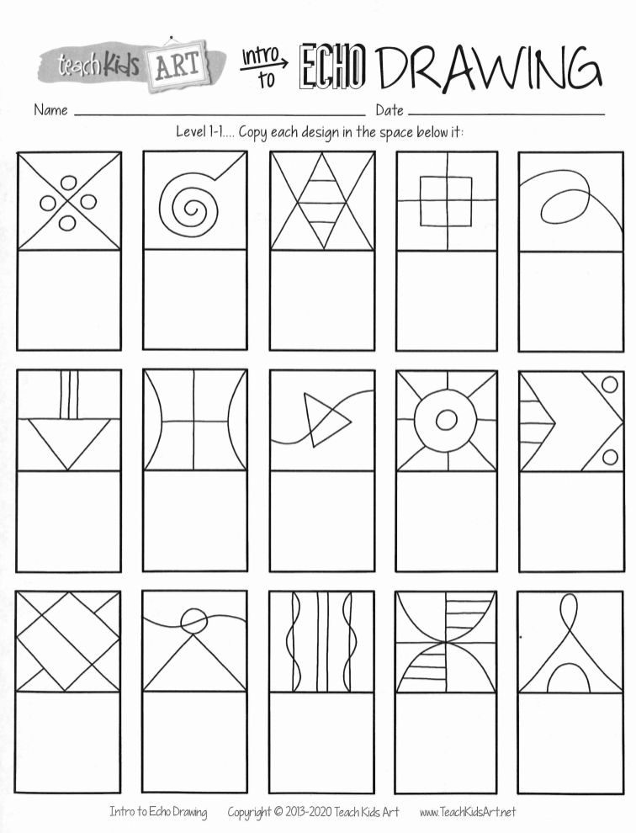
Line Tracing Practice
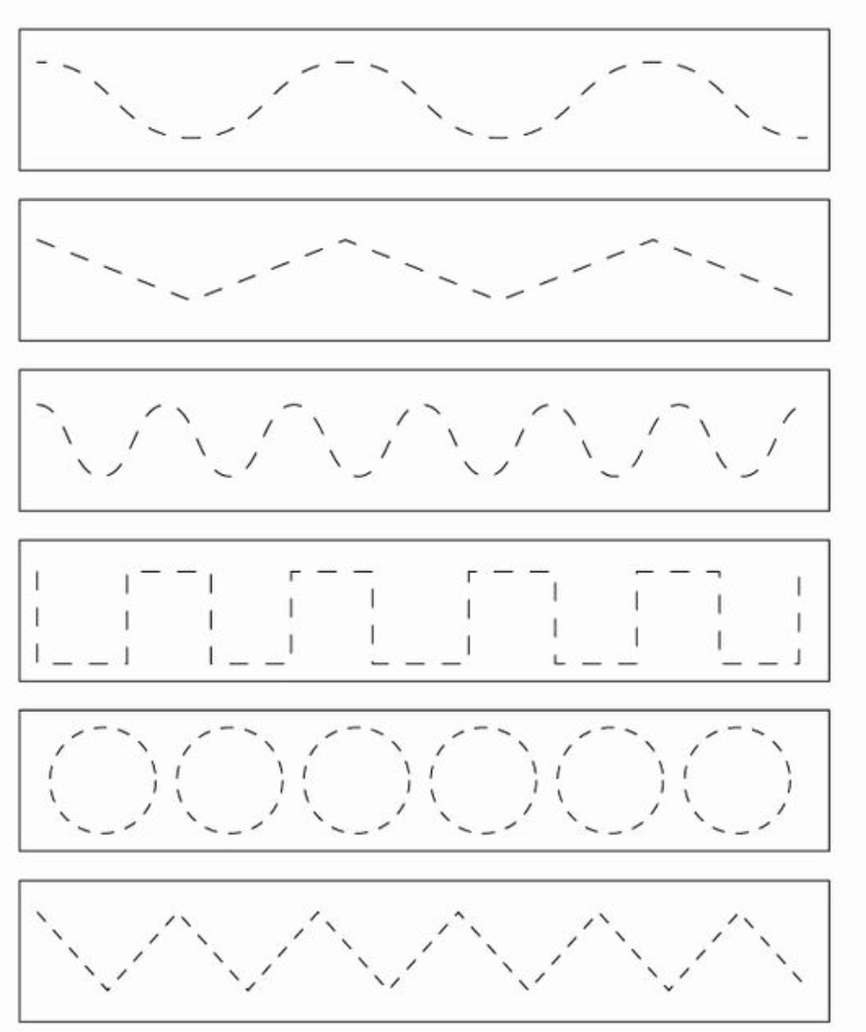
Facial Feature Practice
Look carefully at the image above.
Try to copy the facial features exactly in the space below:
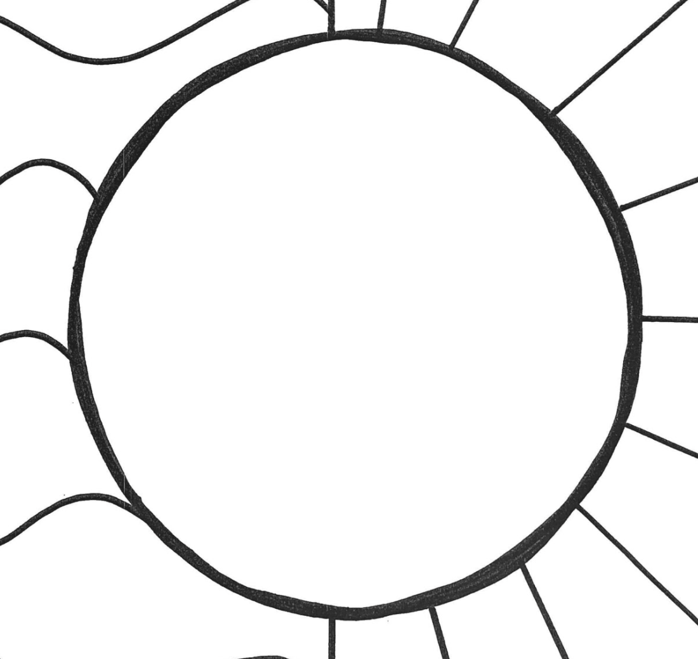
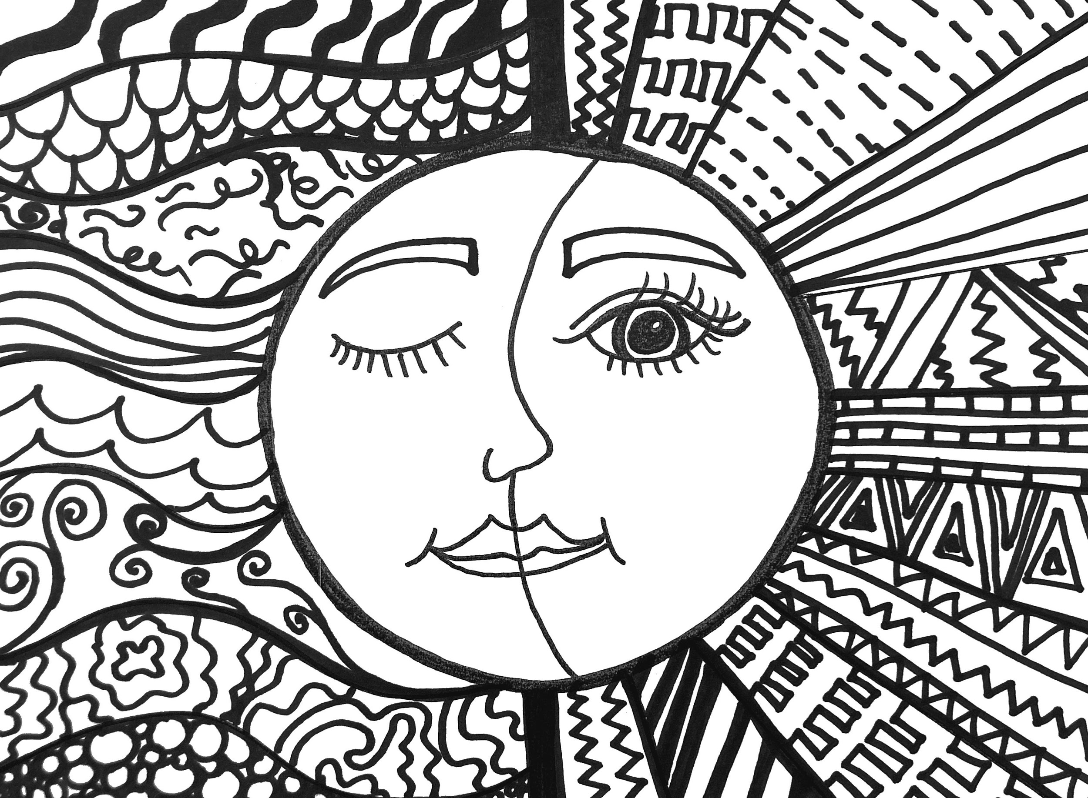

Art Resources for Week Three

In order of use

- Draft sheet (front and back)

- Glow and Grow Reflection

Optional:

- Sun and Moon Coloring Sheet

This Packet Belongs to:
_____________________________________

Name:__________________________

Crew:________________________

Project Title: Warm Sun, Cool Moon

Project Step: Second Draft
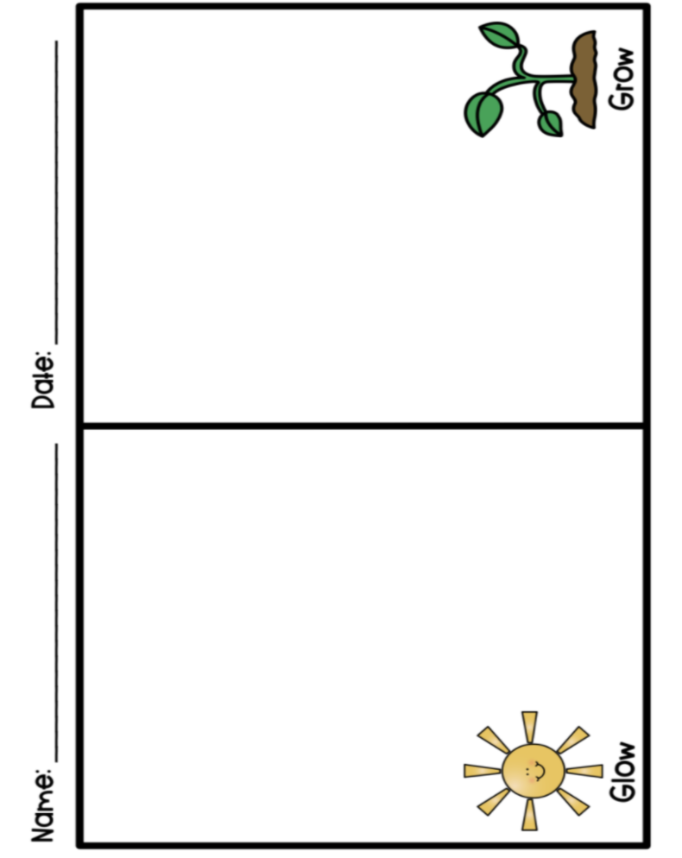

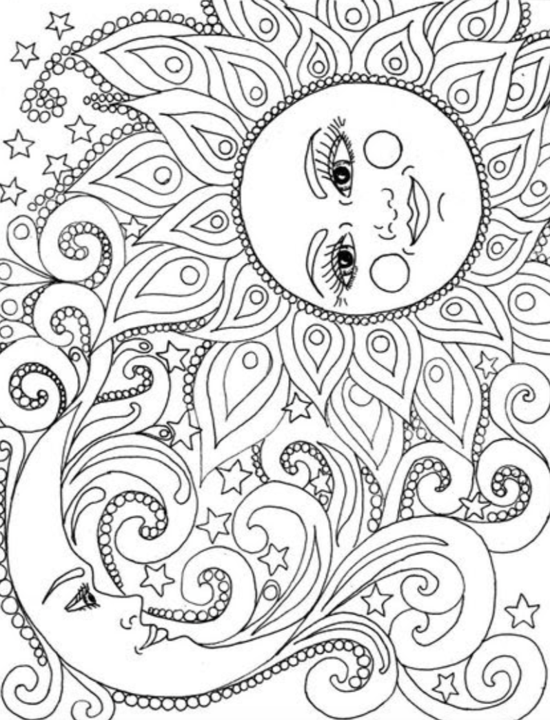

Resources for Week Four

In order of use:

- Ms. Jillian’s Example

- Line Pattern Examples

Due Friday by 8 p.m. in Google Classroom:

- Glow and Grow Reflection

Optional:

- Sun and Moon Coloring Sheet

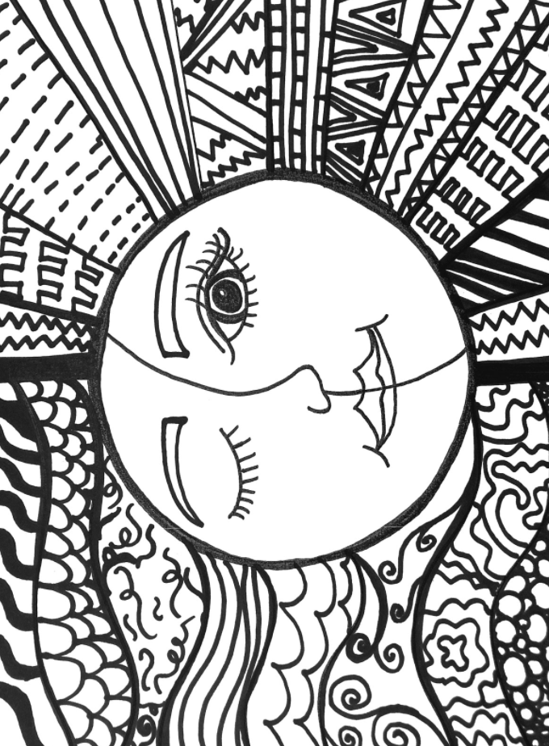

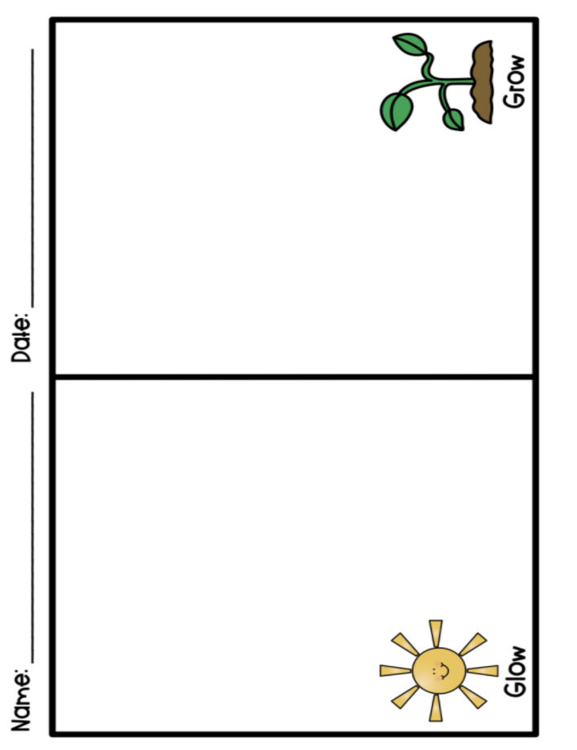
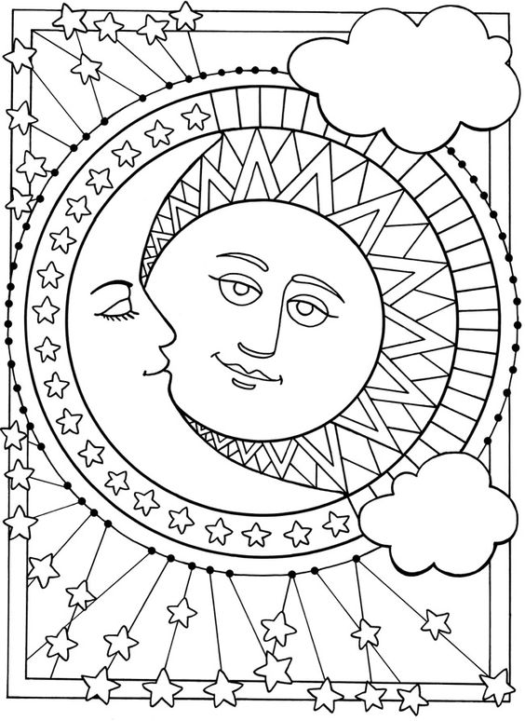

Resources for Week Five

In order of use

Due Friday by 8 p.m. in Google Classroom:

- Glow and Grow Reflection

Optional:

- Warm and Cool Coloring Sheet

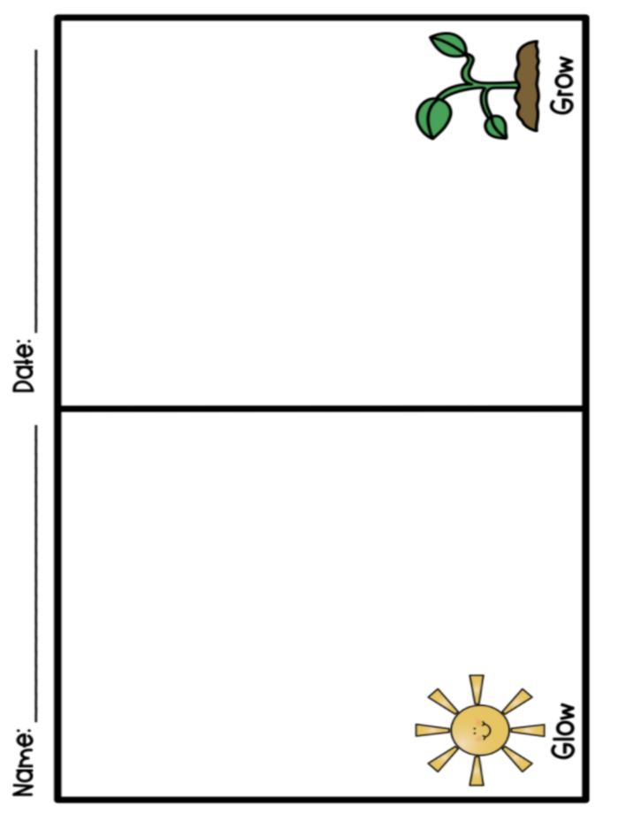
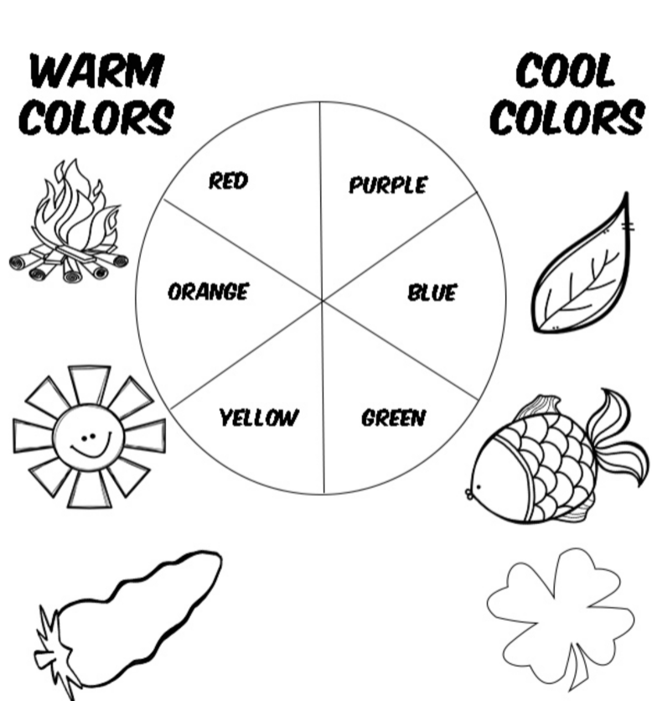

Resources for Week Six

In order of use

Optional:

- Warm and Cool Coloring Sheet
